## horizontal line

## **Robot Movement on a Grid**

# **Problem Statements :**

A robot is moving on a rectangular grid. For testing the intelligence level of robot, there are three locations in the grid are specified as “check-in” points and the robot is supposed to radio a progress report from these points when it is one-fourth, one-half, and three-fourths of the way through it’s tour of inspection.

The robot must begin its tour of the grid from the lower left corner, designated in (row,column) coordinates as (0,0), visiting every other grid location exactly once and ending its tour in row 0, column 1. The robot is able to move only one square per time step in one of the four compass directions: Left, right, up , down.

You are to design a program that determines how many different tours are possible for a given grid size and a sequence of three check-in points.

# **Input Format :**

First line contains integer t which is number of test case.

For each test case, it contains two lines.

First line contains two integers m, n which represents the size of the grid.

Second line contain six integers which is the check in point of the rectangular grid.

**Constraints :**

1<=t<=10

2<= m,n <=8

**Output Format :**

Print the number of tours for each given input similar to the given output below.

# **Sample Input :**

1

3 6

2 1 2 4 0 4

**Sample Output :**

Case 1: 2

**Explanation :**

For given output there are two possible tours exist.

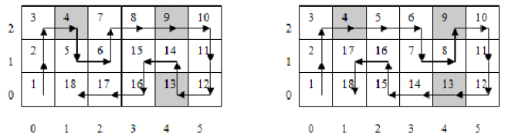

**Time Limit :**

2 sec